INTERCOM PROGRAMMING AND MANUFACTURING COMPANY
(IPMC)
SCHOOL OF CYBERSECURITY | EC-COUNCIL

IPMC

C/CT 2025/2026 ACADEMIC YEAR

COURSE TITLE: CERTIFIED CYBERSECURITY TECHNICIAN (C|CT)

COURSE CODE: 212-82

PROGRAMME: DIPLOMA IN CYBERSECURITY

STUDENT NAME: Tymon Kofi Ansah-Antwi

STUDENT ID:

DATE: 2025/2026

PROJECT TITLE: SECURING GHANA POLICE DATA COMMUNICATION

OVERVIEW

The Ghana Police Service is upgrading its networks. The police service has its main headquarters in the center of the regional capital, and it also operates a regional police headquarters in all 16 regions in Ghana.
Design a secured network that will provide all police staff (including police officers and civilian administration staff), with e-mail, Internet, intranet, storage space, and access to a range of applications via a wired network in each building.
Most staff will have access to all workstations, except for the workstations reserved for senior police officers, and no-one else will have access to the network.

All regional police headquarters will connect to main file storage servers, which are located within the main headquarters, in Accra.
The storage servers hold details of all staff, records of crimes and investigations, as well as permit access to a central police database of known criminals.
Police officers are required to work in the community, and at such times, require access to the network via smartphones in order to access email, records of crimes, etc.

Your role is to design a secure network communication channel, build a secured (harden) server, workstations, design policies and a design a risk management plan the Ghana Police Service.
The detail of your report, and project is given in the tasks below, but you should provide a range of options for the Ghana Police Service to make a choice and recommendations as to which you think is the best option.

Executive Summary

The Ghana Police Service (GPS) is upgrading its national and regional communication networks to support secure data access and transfer across all 16 regions and the central headquarters in Accra. This report presents a comprehensive secure network design to protect sensitive police data, including staff records, crime reports, and the national criminal database.

The proposed solution ensures that staff can securely access email, intranet, storage, and applications via wired and mobile connections, while enforcing strong authentication, encryption, monitoring, and risk management. The report highlights vulnerabilities, mitigation strategies, and organizational policies that will safeguard the confidentiality, integrity, and availability of police data.

PROJECT SCOPE
This project is about building a safe and reliable communication system for handling sensitive police or security information. It includes:
- Ensuring GPS communication is secure.
- Securing data storage and sharing between the regional offices and the main office
- Enabling officers to be safely connected to the system
- Drawing a network map that shows how everything connects securely.
- Setting up strong logins and access controls so only the right people can use the system.
- Developing policies to safeguard data, monitor issues, and remain functional to the regulations
The system needs to be scalable, secure, and dependable so it can handle important records, staff details, and operational messages.

Network Security Requirements

What the network must do:
- Keep data private (Confidential).
- Outsiders should not be allowed to see the Police Data such as crime records staff details and criminals databases
- This information should only be accessed by authorised police officers and should be encrypted to prevent hackers to read it
- Stop changes by outsiders (Integrity).
- Evidence, Crime Reports and Investigation Details should not be changed or corrupted
- Security controls should make sure data sent between Accra and regional HQs arrives exactly as it was sent, without tampering.
- Always be working (Availability).
- The system should be available to the officers both when in the office and in the field.
- The network should be backed up and have reliable connections so that services (like email, storage, and database access) do not fail.

- Only staff can log in (Authentication).
- The system must make sure that the individual who is logging in is 100% an authorised personnel
- Multi-factor login may be a password or biometric which ensures that outsiders do not access the system

- Keep phones and remote access safe.
- Police officers using smartphones in the community must connect securely to the central network.
- Sensitive data will be secured by VPNs, encryption of devices, and rules of mobile security (such as remote wipe in case of theft).

- Follow Ghana’s data protection laws.
- The system should be based on the Ghana Data Protection Act (2012), which says how personal data of victims, suspects, and officers should be handled.
- This includes proper storage, limited access, regular audits, and ensuring privacy is respected at all times.

Proposed Network Security Topology Diagram

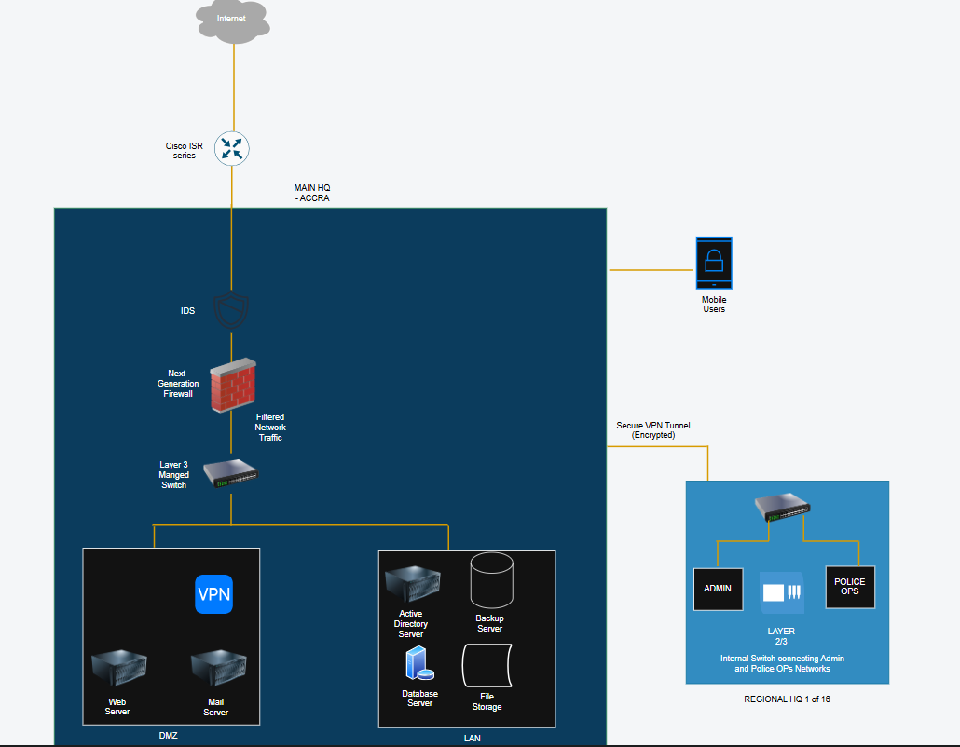

Explanation:

The Internet represents all external and untrusted connections trying to access the Ghana Police network.
The first device traffic reaches is the Core Router.
The Core Router connects the police network to the Internet and directs incoming and outgoing traffic.
It determines where traffic should go but does not make deep security decisions.

After the Core Router, traffic passes through the IDS/IPS.
The IDS/IPS monitors all incoming traffic for:
- Hackers
- Malware
- Suspicious activity
- Known attack patterns

Next, the traffic moves to the Next-Generation Firewall.
The firewall is the main security control. It:
- Filters traffic based on security rules
- Inspects data deeply
- Understands applications
- Blocks unauthorized access
- Prevents malicious traffic
Only safe and approved traffic is allowed to continue.

After the firewall, traffic reaches the Layer 3 Switch.
The Layer 3 Switch separates the network into different sections for better security and control.
At this point, the network splits into:
- The DMZ
- The Internal LAN

The DMZ contains public-facing servers such as:
- Web server
- Mail server
- Public storage server
These systems can be accessed from outside but are isolated from sensitive internal systems.

The Internal LAN contains highly sensitive systems such as:
- Police crime database
- Internal file storage
- Administrative systems
This area is strongly protected and not directly accessible from the Internet.

On the right side of the diagram, each Regional Headquarters connects securely to the main office through a VPN tunnel.
Inside each regional office, the network is separated into:
- Admin Network
- Police Operations Network
This prevents unauthorized access between departments.

Mobile Users connect securely using SSL VPN, allowing officers in the field to access emails and crime records safely using encrypted communication.
All possible network security issues and vulnerabilities

- Unauthorized access to sensitive databases.
- Hackers could breach the police database and obtain private information about crimes, suspects, and officers. (Strong protections need to be in place)
- Insider threats from staff with excessive privileges.
- Some staff may have more access than they require. They might intentionally misuse this to view, copy, or leak information

- Weak or reused passwords leading to breaches.
- If police staff use easy or repeated passwords, hackers can easily guess them and break into the system.
- Interception of during transfer between regions.
- Attackers could intercept and steal data sent between Accra headquarters and the 16 regional headquarters if it is not encrypted.
- Mobile device theft or compromise.
- If a police officer’s phone is stolen or hacked, criminals could use it to access police systems and sensitive data which could lead to major issues
- Malware and ransomware attacks on servers.
- Attackers might install malicious software on police servers to steal data, destroy systems, lock files, and demand money. Such malicious software end up corrupting servers badly.
- Lack of continuous monitoring and patching.
- If the police IT team doesn’t regularly check the network for threats and update systems, hackers could exploit weaknesses and gain access.

Security Mitigation Plan

- Encryption: End-to-end encryption for all data in transit and at rest.
- All police data is supposed to be encrypted in such a way that nobody can understand it in case it is stolen or intercepted.
- Encryption is used to secure to files stored in servers and data being sent between Accra HQ, regional HQs, and officers in the field.
- VPN with MFA: Secure tunneling with strong authentication for remote access.
- Police officers connecting from outside must use a VPN to create a private, secure connection.
- They must also pass the multi-factor authentication like password + code or fingerprint to prove they are real officers.

- Access Control: Role-based access with least privilege principle.
- Every officer or staff member only gets access to the data they need for their job.
- For example, a regional officer can’t access top-secret files of senior officers in Accra.
- Endpoint Protection: Deploy antivirus, EDR, and mobile device management (MDM).
- All computers and phones used by police should have antivirus and anti-hacking programs.
- MDM (Mobile Device Management) makes it possible to track, lock, or erase data on a stolen police phone.

- Firewalls & IDS/IPS: Perimeter and internal monitoring for threats.
- Firewalls act as a security guard preventing suspicious traffic.
- IDS/IPS (Intrusion Detection/Prevention Systems) monitor the network for abnormal activity and can prevent any attack before it is damaging.
- Regular Patching: Automated updates for OS and applications.
- All police computers, servers, and applications should be updated on weekly basis.
- Holes that can be exploited by hackers are regularly updated.
- Incident Response Plan: Established procedure of detecting threats, escalating and recovering

In case of a cyberattack, a step by step plan must exist:
- Detect the attack.
- Report it quickly.
- Contain and fix the problem.
- Recover data and systems.
- Examine the experience to prevent it in the future.

Security Controls To Secure And Harden Servers, Softwares, Devices

- Enforce secure workstation builds using group policy configurations.
- Strict security settings should be set on all police computers.
- For example, turn off unneeded features, block unsafe applications, use strong passwords, and lock the screen when it is not in use.
- This causes every police computer to follow the same rules and are harder to hack.
- Deploy firewalls on endpoints and servers.
- A firewall is like a guard which monitors incoming and outgoing network traffic.
- All computers and servers must have a firewall to block suspicious or unauthorized connections.
- This prevents sneak attacks by hackers

- Use SSL/TLS for all web-based applications.
- Any police website or web app must use HTTPS.
- This means the personal data sent between users and the server is protected and cannot be read by attackers.

- Apply disk encryption on laptops and mobile devices.
- The laptops, tablets, and smartphones of the police staff must be encrypted.
- If a device is lost or stolen, the data inside (like reports or emails) cannot be accessed without the decryption key.

- Regular Patch Management
- All police servers, apps and computers must be kept up to date.
- Security patches should be installed quickly to fix vulnerabilities which prevents hackers from exploiting the system.

- Role Based-Access and Multi-Factor Authentication
- Staff accounts should only access the system they need for their jobs.
- The most important systems should demand MFA (password + code or fingerprint) so that even in case a password is stolen the attacker is not able to log in.

- Endpoint Protection Software
- All devices must have an antivirus and Endpoint Detection and Response tools.
- These tools detect and block viruses and suspicious activity.

Data Protection Issues Of The Central Criminal Database

- Exposure of sensitive personal data (Victims, Suspects, Officers).
- The database stores private details like names, addresses, and case records.
- If the system is hacked or not well protected, this information could leak to the public or criminals, putting people at risk.
- Risk of insider misuse of criminal records
- Some staff who already have access could use it wrongly.
- For example, an officer might look up records they don’t need for their job or even share information with outsiders.
- Unauthorized third-party access.
- Hackers, or unauthorized organizations might break into the system.
- If they succeed, they could steal, change, or delete criminal records.

- Data replication errors across regional headquarters.
- The database in Accra shares information with all 16 regional HQs.
- If the data is not replicated correctly, some regions may have missing, outdated, or incorrect records which could lead to errors in police work

- Privacy law compliance (Data Protection Act, Ghana 2012).

- Malware/Ransomware threats
- Attackers could lock or destroy records for ransom.

- Backup and recovery gaps
- If backups are missing or insecure, data could be lost permanently.

7 Data Protection Security Controls To MItigate Our Identified Data Protection Issues

- Encryption - All the personal data of victims, suspects and officers are encrypted in the database such that in case they are stolen, the data is unreadable.
- Role-Based Access Control with least privilege - The staff can only access the records needed for their jobs. The access to senior officers is more and the access to regular officers is limited
- Multi-Factor Authentication and Strong Firewalls - Requires extra verification (like password + code/biometric) and blocks external intrusions.
- Database Synchronization and Integrity Checks - Automated tools verify that copies match the main database and flag differences or errors.
- Data Governance and Compliance Audits - Regular reviews ensure all handling of personal data follows the Ghana Data Protection Act (2012)
- Endpoint and Server Security - Servers and devices are regularly updated, monitored using intrusion detection, and protected with anti-malware.
- Secure Backup Plan - Many encrypted backups are stored in safe locations that include offline copies in order to quickly restore systems if data is lost or attacked.
Detailed Description Of User And Device Authentication Security Controls

User Authentication Security Controls

These are controls that make sure only real police staff can log in:

- Multi-Factor Authentication
- Staff must use two checks to log in (password + fingerprint/code)
- This prevents hackers from getting access even if they have stolen a password

- Strong Password Policy
- All accounts must use long, complex passwords (mix of letters, numbers, and symbols).
- Passwords must expire every 60-90 days and the system should block reused ones

- Role-Based Access Control
- Staff only get access to what they need

- Account Lockout And Monitoring
- If someone tries the wrong password too many times, the account locks.
- Logs are kept of all login attempts for auditing

- Single Sign-On
- Officers can log in once to access multiple apps securely
- This reduces password fatigue and lowers risk of weak/reused passwords

Device Authentication Security Controls

These ensure that only trusted devices (police computers, phones, laptops) can connect to the network:

- Digital Certificates for Devices
- Each police device is issued a digital certificate (like an ID card).
- Devices without valid certificates cannot connect to the police network.
- Mobile Device Management (MDM)
- All police phones and tablets are registered in an MDM system.
- The MDM enforces rules like screen lock, encryption, VPN use, and remote wipe if a device is stolen.
- Disk and Device Encryption
- Police laptops and smartphones should be encrypted.
- If stolen, the hacker cannot read any files without the encryption key.

A well documented 5 types of policies you will be implement and 7 examples of each policy

- Password Management Policy
This policy ensures strong and secure password use.

- Passwords must be at least 12 characters long
- Passwords must not be shared
- Old passwords cannot be reused
- Passwords should expire every 60 days
- Must include a mixture of uppercase, lowercase, numbers, and symbols
- Default passwords on new devices must be changed immediately
- Passwords should be memorised and not written down in plain text

- Mobile Device Policy
This policy ensures secure use of the police smartphones, tablets and laptops.

- All the police devices must be encrypted
- Lost or stolen devices must be reported within an hour
- Devices must connect to the network using a VPN
- Only apps that are IT approved may be installed
- All devices must have a screen lock
- All devices must always be updated with the latest patches
- Police data should not be saved on personal devices

3. User Account Management Policy
This policy ensures the rules for creating and managing user accounts.

- New accounts must be approved by HR and IT
- Each staff member must have only one active account
- Shared accounts are not allowed
- Temporary accounts must expire automatically
- Accounts of ex-staff must be disabled immediately
- Privileged accounts must be monitored more closely
- All accounts should have strong password polices

4. Incident Response Policy
This policy shows how to encounter cyber attacks.

- All staff must report all suspicious activity immediately
- An Incident Response Team must investigate security alerts.
- Incidents must be escalated according to severity.
- Evidence must be preserved for investigation.
- Compromised systems must be isolated immediately.
- A post-incident report must be prepared within 48 hours.
- Lessons learned must be reviewed to improve security.

`5. Data Protection Policy
This policy protects sensitive police data.

- All sensitive data must be encrypted in storage and during transfer
- Only authorised police staff may handle and process sensitive information
- Data that is not longer wanted must be securely deleted
- Crime records shouldn’t be shared through unauthorised apps, e-mails or USB drives
- Staff must follow the Ghana Data Protection Act, 2012 (Act 843) at all times
- Backups should be encrypted and stored securely in approved locations
- Victim and Witness details must be treated with the highest level of confidentiality and care

Configurations Done In Project Practical session

Server Configuration
- Rename Default Admin Account:
- Open Computer Management -> Local Users and Groups -> Users
- Right-click Administrator, select Rename.
- Enter new name

- Disable Guest Account
- In Local Users and Groups -> Users
- Right-click Guest, select Properties
- Check Account is disabled -> Click Ok.

- Password and Account Lockout Policy
- Open Group Policy Management -> Create or edit a GPO linked to your domain or server
- Navigate to Computer Configuration -> Windows Settings -> Security Settings -> Account Policies
- Password Policy: Minimum Password Length, Password complexity enabled and Maximum password age
- Account Lockout Policy: Account lockout threshold (3-5), Lockout Duration and Reset account lockout counter after X minutes

- Enable Firewall
- Open Windows Defender Firewall with Advanced Security
- On the left, select Inbound rules -> Enable existing rules for Remote Admin if needed
- On the right, click Properties -> set Domain, Private, and Public profiles to On.
- Optionally, disable allow exceptions by not creating any inbound rules except required ones

- Enable Auditing
- Open GPO, edit your GPO -> Navigate to Computer Configuration -> Windows Settings -> Security Settings -> Advanced Audit Policy Configuration -> Audit Policies
- Enable logon/logoff -> Success, Failure
- Account Management -> User Account Management (Success, Failure)
- Object Access -> Removable storage + File Access ( Success, Failure)

- Automatic Updates
- Open Settings -> Update & Security -> Windows Update -> Advanced Options
- Set Automatic Updates to install every Tuesday

- Restrict Remote Desktop
- Open System Properties -> Remote -> Remote Desktop
- Select Allow connections only from computers running Remote Desktop with Network Level Authentication
- Control access via Remote Desktop users group

- Antivirus
- Install enterprise antivirus on all PCs
- Configure: Real-time protection (ON), Scheduled scans (Weekly), Automatic updates (On)

- Certificate Authority
- Open Server Manager -> Add Roles and Features
- Select Active Directory Certificate Services
- Configure Certification Authority (Role Services: Certificate Authority and Type: Enterprise Root CA)
- Complete the wizard and publish the CA.

- Server Backup
- Open Windows Server Backup
- Select Backup Schedule -> Weekly/Daily -> Choose Full Server
- Set destination and enable notifications for backup success/failure.
- Wireshark (Network Monitoring Tool)
- It helps to observe network activity and detect any suspicious or unusual traffic.

- ADAudit Plus (Monitoring tool to track user activities)
- It helps identify unauthorized access and keeps records of user actions for security purposes.

- VPN (Client-To-Site)
- Creates a secure connection between a client machine and server.
- A VPN encrypts data and allows the client access the network safely

- Manage Log360 (Security Information and Event Management tool)
- Collects and analyses logs from different systems in one place
- It gathers data such as user activity, network devices, and servers and analyses this data to detect suspicious behaviour.

Officer/Investigator/Admin Polices (via Group Policy)
- Ctrl + Alt + Del requirement
- User Configuration -> Administrative Template -> System -> Ctrl+Alt+Del Options -> Enable “Require Ctrl+Alt+Del”

- Idle Lock
- User Configuration -> Administrative Template -> Control Panel -> Personalisation -> Screen Saver timeout
- Officers: 5 min
- Investigators/Admins: 5-10 mins

- USB Storage
- Block USB: Computer Configuration -> Administrative Template -> System -> Removable Storage Access -> Deny All Access (Officer)
- Allow USB: Leave Default or specifically allow read/write (Investigator/Admin)

- File Share Access
- Create and Share a folder
- Set NTFS & Share Permissions per role:
- Officer: Read Investigator: Read/Write Admin: Full Control

- Password Policies
- Investigator: Enforce complexity (at least uppercase, lowercase, numbers, symbols).
- Admin: Minimum 16 characters

- Audit Logs
- Ensure Audit Logs are visible in Event -> Security
- Can also forward logs to a central server if desired

